D1- Downtown Core
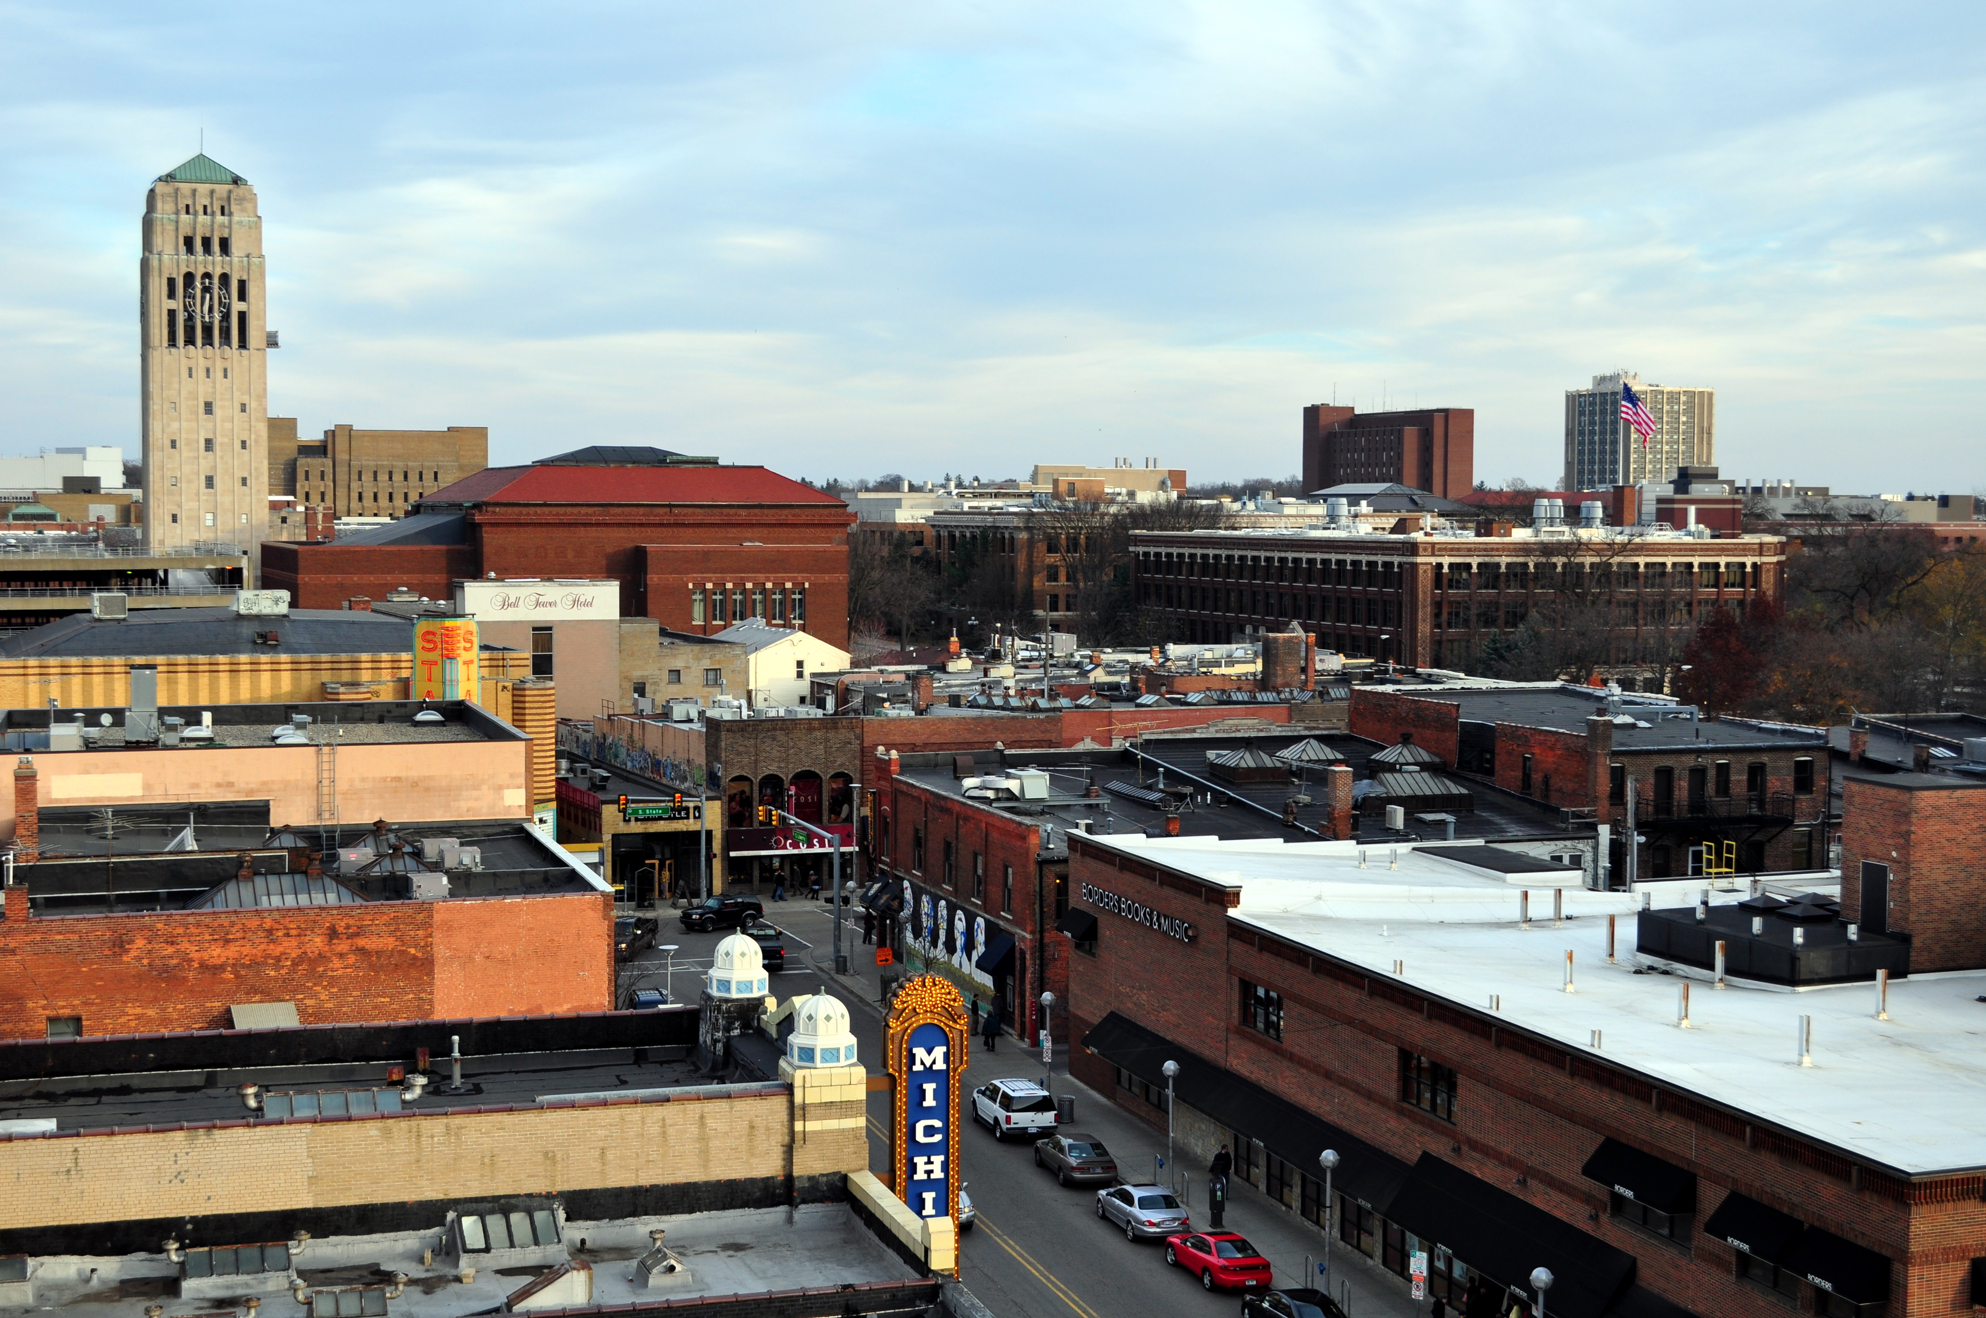
-Form Regulations
Maximum Height: 150-180 ft depending on character overlay.
Maximum Building Coverage (percent of lot area): None
Floor Area Requirement (percent of lot area): Maximum 400%, up to 900% with premiums.
Minimum Lot size: None
Minimum Open Space (percent of lot area): None
Minimum Parking Spaces: None unless premium is reached. Then 1 per 1000 square feet of premium floor area
Minimum setbacks: 0-30 ft depending on character overlay.
Downtown zones are divided into character overlay zones that have slightly different rules.
Downtown buildings must follow design guidelines and be approved by the design review board.

Allowed: Most residential and commercial uses that are NOT parking structures, erotic businesses, medical marijuana dispensaries, or warehouses. Medical Marijuana dispensaries are allowed if special conditions are met. The planning commission may give a parking structure a special exemption.

The Unified Development Code, which is a reorganization of Ann Arbor zoning and development laws, lists slightly fewer permitted uses than the existing code. Industrial facilities, hospitals, laboratories, agricultural or outdoor recreation areas are not D1 permitted uses in the Unified Development Code. The unified development code has not yet been adopted, but it may be soon. Existing Rules. Unified Development Code (under 5:15).

Maximum unrelated people per dwelling unit: 6.
Co-ops and other group housing: Allowed

D2 – Downtown Interface
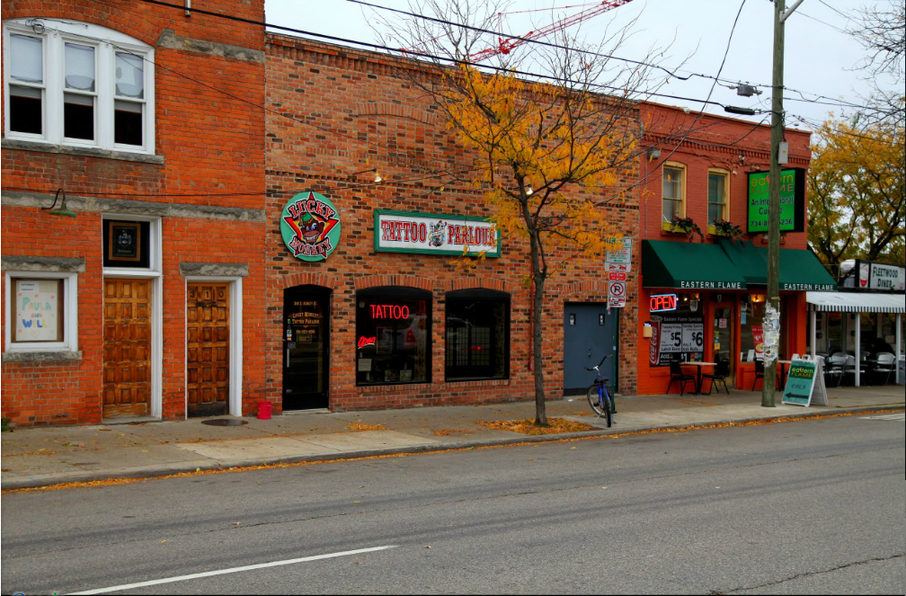

Form Regulations:

Maximum Height: 60 ft
Maximum Building Coverage (percent of lot area): 80%
Minimum Lot size: None
Minimum Open Space (percent of lot area): 10%
Floor Area Requirement (percent of lot area): Maximum 200%, up to 400% with premiums.
Minimum Parking Spaces: None unless premium is reached. Then 1 per 1,000 sqft. of premium floor area.
Minimum Setbacks: 5-30 ft. depending on character overlay.
Downtown buildings must follow design guidelines and be approved by the design review board.

-Use Regulations
Allowed: Most residential and commercial uses that are NOT parking structures, erotic businesses, medical marijuana dispensaries, or warehouses. Medical Marijuana dispensaries are allowed if special conditions are met. The planning commission may give a parking structure a special exemption.

The Unified Development Code, which is a reorganization of Ann Arbor zoning and development laws, lists slightly fewer permitted uses than the existing code. Industrial facilities, hospitals, laboratories, agricultural or outdoor recreation areas are not D2 permitted uses in the Unified Development Code. The unified development code has not yet been adopted, but it may be soon. Existing Rules. Unified Development Code.

Maximum unrelated people per dwelling unit: 6
Co-ops and other group housing: Allowed

R4C Multifamily Residential

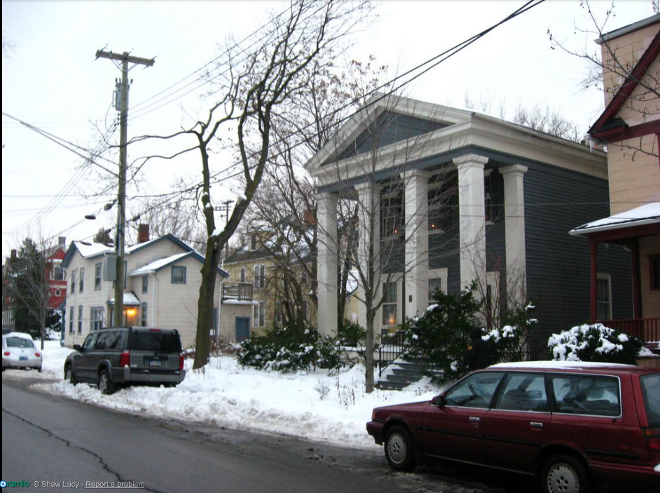
-Form Regulations
Maximum Height: 30 ft.
Maximum Building Coverage (percent of lot area): None
Floor Area Requirement (percent of lot area): None
Minimum Lot size: 8,500 sqft. and the lot must be at least 60 ft. wide. 2,175 sqft. per dwelling unit.
Minimum Open Space (percent of lot area): 40%. 300 sqft. of open space per dwelling unit is also required.
Minimum Parking Spaces: 1.5 spaces per dwelling unit.
Minimum Setbacks in ft.: Front=25 Rear=30 Sides=12 and houses must be at least 20 ft apart

-Use Regulations
Allowed: Single and Multifamily housing, libraries, and religious assemblies,
Allowed with permission from the planning commission: private schools, hospitals, non-profit offices, and outdoor recreation areas.
Allowed with restrictions: Home occupations that do not use more than 25% percent of the building, do not generate more than ten vehicle trips a day, and do not involve reselling goods.
Maximum unrelated people per dwelling unit: 6
Co-ops and other group housing: Allowed.

C2B Business Service District
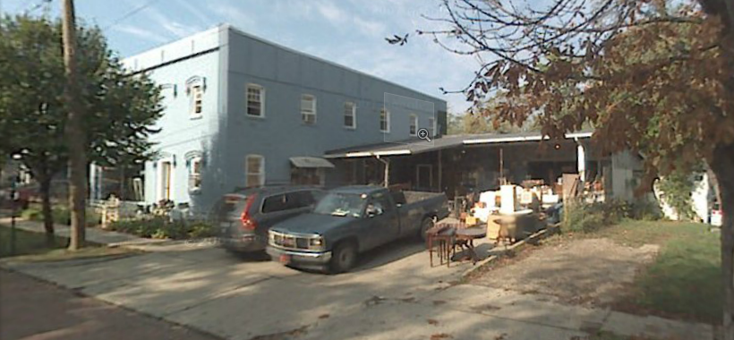
-Form Regulations
Maximum Height: 55 ft.
Maximum Building Coverage (percent of lot area): None
Floor Area Requirement (percent of lot area): Maximum 200%
Minimum Lot size: 4,000 square ft. and the lot must be 40 ft. wide.
Minimum Open Space (percent of lot area): None
Minimum Parking Spaces: 1 space for about every 100-300 square ft of floor area (depends on type of use)
Minimum setbacks: None except 30 ft. for each side next to a residentially zoned property, plus one further foot for each foot of building height over 30.

-Use Regulations
Allowed: Retail businesses and all the uses allowed in residential zones.
Maximum unrelated people per dwelling unit: 6
Co-ops and other group housing: Allowed

M1 Limited Industrial
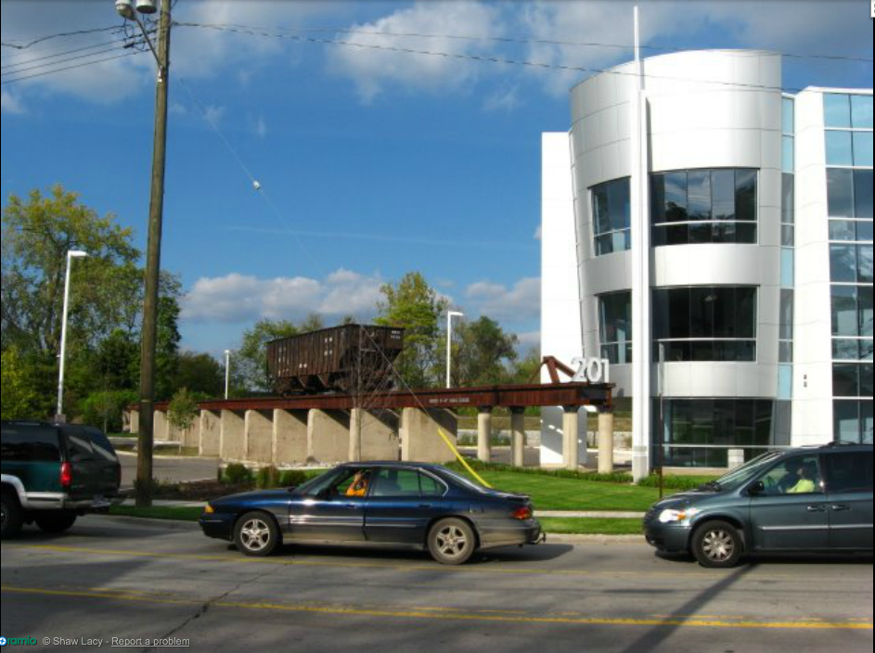
205 depot st.

-Form Regulations
Maximum Height: 35 ft.
Maximum Building Coverage (percent of lot area): 40%
Floor Area Requirement (percent of lot area): Minimum 75%
Minimum Lot size: 13,000 sqft. and at least 100 ft. wide.
Minimum Open Space (percent of lot area): None
Minimum Parking Spaces: For industry, 1 space for every 1500 sqft. of floor area.
Minimum Setbacks in ft.: front=15 Rear=0, but 50 next to residential zones sides=0, but 30 next to residential zones.

-Use Regulations
Allowed: government offices, libraries, schools, and light manufacturing that does not create more noise, heat, and glare than already exists at the lot lines.

R2A Two-Family Residential

-Form Regulations
Maximum Height: 30 ft.
Maximum Building Coverage (percent of lot area): None
Floor Area Requirement (percent of lot area): None
Minimum Lot size: 8,500 sqft. and at least 60 ft. wide. 4250 sqft. per dwelling unit.
Minimum Open Space (percent of lot area): None.
Minimum Parking Spaces: 1.5 spaces per dwelling unit.
Minimum Setbacks in ft.: Front=25 Rear=30 Sides=5 and houses must be at least 20 ft apart. Lots with two structures have larger setbacks.

-Use Regulations
Allowed: Single Family Housing, Two-Family housing, libraries, and religious assemblies,
Allowed with permission from the planning commission: private schools, hospitals, non-profit offices, and outdoor recreation.
Allowed with restrictions: Home occupations that do not use more than 25% percent of the building, do not generate more than ten vehicle trips a day, and do not involve reselling goods.
Maximum unrelated people per dwelling unit: 4
Co-ops and other group housing: Not Allowed

R1C Single-Family Residential

-Form Regulations
Maximum Height: 30 ft.
Maximum Building Coverage (percent of lot area): None
Floor Area Requirement (percent of lot area): None
Minimum Lot size: 7,200 sqft. and at least 60 ft. wide. The R1 B zone requires 10,000 sqft. and the R1A requires 20,000 sqft.
Minimum Open Space (percent of lot area): None.
Minimum Parking Spaces: 1
Minimum Setbacks in ft.: Front=25 Rear=30 Sides=5 and houses must be at least 20 ft apart.

-Use Regulations
Allowed: Single-Family Housing, libraries, and religious assemblies,
Allowed with permission from the planning commission: private schools, hospitals, non-profit offices, and outdoor recreation.
Allowed with restrictions: Home occupations that do not use more than 25% percent of the building, do not generate more than ten vehicle trips a day, and do not involve reselling goods.
Maximum unrelated people per dwelling unit: 4
Co-ops and other group housing: Not Allowed

